Robert L. Ross Memorial Scholarship
Application 2017

Due September 15, 2017

Provided by:

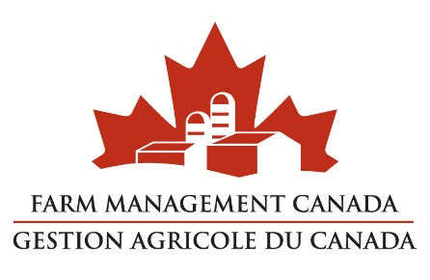
The Family of Robert L. Ross

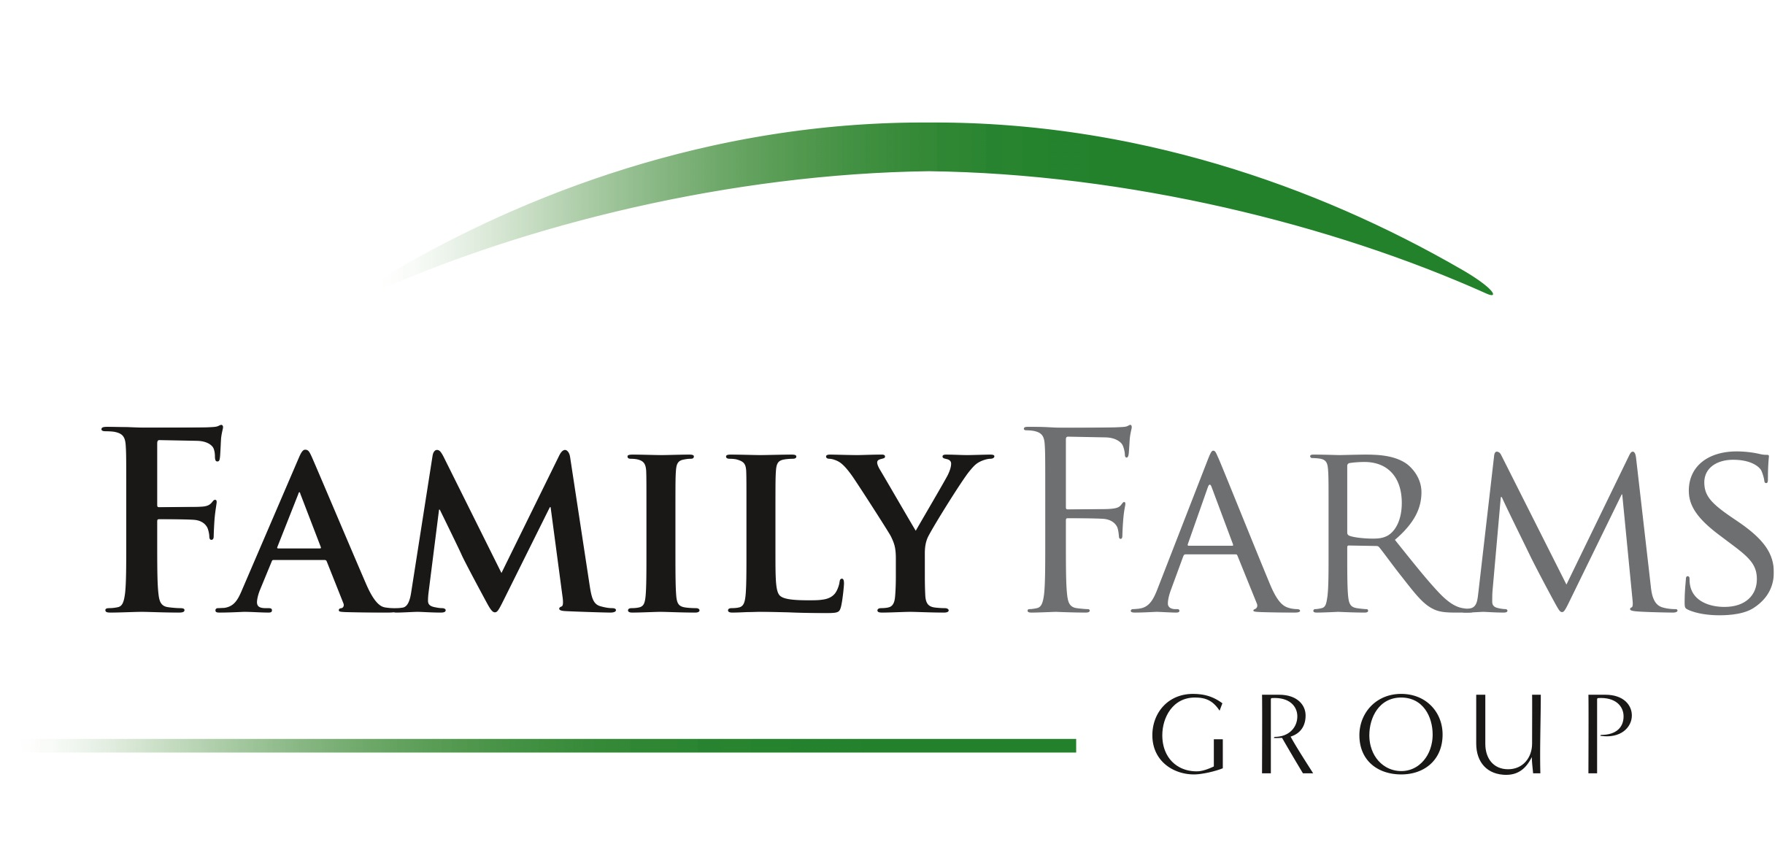

The Robert L. Ross Memorial Scholarship
Robert (Bob) Ross was instrumental in guiding the CTEAM program, inspiring and encouraging farm management excellence across Canada through his leadership and passion for the agricultural community. Bob fought a courageous battle with cancer, passing in March 2014.
As a tribute to his passion, leadership and legacy, Agri-Food Management Excellence, Farm Management Canada, Family Farms Group and the Ross Family, along with an additional private contributor this year, have established the Robert L. Ross Memorial Scholarship program, rewarding two Canadian farmers with the opportunity to participate in the CTEAM program and continue on a path towards excellence, as inspired by Canada’s leading experts and a one-of-a-kind support network of peers and colleagues.
Award Components:
One scholarship of $11500 CAN to be applied towards tuition and travel. The successful applicant can choose to attend CTEAM starting in December 2017.
Criteria:
The Robert L. Ross Memorial Scholarship will be awarded to one deserving farmer who emulates and demonstrates Bob’s lifework through their passion and devotion to excellence in farm business management. The award is intended to encourage existing or relatively new farmers who have increasing or major responsibilities in their operations. This includes either farmers who have overall managerial responsibility for their operations or newly entering farmers who have responsibility for specific portions of farm operations. Applicants should demonstrate a desire for managerial excellence in their current and future responsibilities.
Scholarship applicants must:
- Be over 21 years of age
- Submit an application demonstrating
  - A progressive operation and entrepreneurial spirit
  - How the value gained from CTEAM will be used:
    - To contribute to the farm business
    - To contribute to the agricultural industry at large
  - Why taking CTEAM interests you personally
  - Passion for the industry
- Submit 2 non-family letters of reference
- Provide permission to be interviewed for industry media
- Provide a testimonial or report on their experience and impact of the Scholarship within 3 months of program completion, crediting the scholarship partners for making the opportunity possible
- AME Contract Staff, FMC Board and staff, and FFG staff are not eligible to apply.

Application Process:
- Applicant must submit a completed application form along with 2 non-family letters of reference
- Deadline for scholarship applications is September 15th, 2017. The application must be received by email to heather@agrifoodtraining.com or by mail to Agri-Food Management Excellence, R.R.1, Donalda, AB, T0B 1H0
- If an email is provided, you will be notified acknowledging receipt of your application
- If you have any questions, please email heather@agrifoodtraining.com or call Heather Broughton at (780)781-2840
- Winner will be notified prior to September 29th, 2017 and will be publicly announced at the Agricultural Excellence Conference Banquet in Ottawa, ON, November 22th, 2017.
This scholarship can be used in conjunction with Growing Forward 2 and other government funding. We encourage applicants to check with their provincial authorities on application procedures for these funds. Especially in Ontario it is important to apply early (June/July) for these funds.

Deadline for the application is September 15th, 2017. Applications received after this date will not be considered.

The Robert L. Ross Memorial Scholarship
Application 2017

Name:
Farm Name:
Mailing Address:
Email: Daytime Telephone Number:
Describe how your operation is progressive and provide evidence of your entrepreneurial spirit:

How will you use the value gained from the program:
• To contribute to your farm business?
• To contribute to the agricultural industry at large?

Why does taking CTEAM interest you personally?

Describe your passion for the industry and how you exemplify it:

Statement of Accuracy
I hereby affirm that all the above stated information provided by me is true and correct to the best of my knowledge. If awarded, I also consent and give my permission to be interviewed by industry media. I will also provide a testimonial or report on my experience and impact of the Scholarship, crediting program partners for making the opportunity possible.

Signature of scholarship applicant: ___________________________________________

Date: ________________________

Agri-Food Management Excellence (AME) is inspired by empowering people to realize their goals. We empower farmers, ranchers and other agribusiness professionals through leading edge courses delivered in an unconventional format. It is Canada’s only national farm management learning program.
Farm Management Canada is a national umbrella for farm business management activity and the only organization dedicated exclusively to the development and delivery of advanced business management information, tools and resources to position Canada’s farmers for success.

Thank you for your submission.

